# 7PAM2000-0901-2023 - Applied Data Science 1 - Assignment 2: Statistics and trends

# CLIMATE CHANGE ANALYSIS ON WORLD BANK DATA

# BY

# AISHWARYA SUKUMARAN

# STUDENT ID: 22058088

# Email: [as23adl@herts.ac.uk](mailto:as23adl@herts.ac.uk)

[**Github**](https://github.com/AishwaryaSukumaran/AishwaryaSukumaran_ADS1_Assignment-2)

[DataSource](https://data.worldbank.org/topic/climate-change)

The assignment focuses on visualising and analysing the data from climate change produced by world bank. Here we will look into the different features of the data via charts, plots and tables.

For initialising, this table shows the total population count of different countries over different years.

LINE GRAPH 1: Here for comparison, I have taken different countries like Australia, Canada, France, United Kingdom, India, Japan and United states over the year span of 1970 to 2020. Let’s first look into the comparison of CO2 emission based on total population.

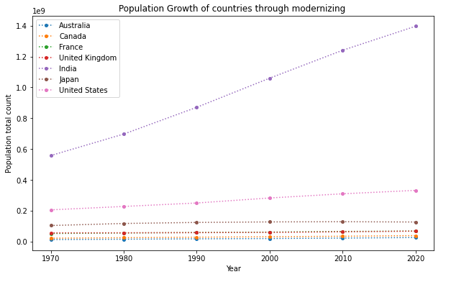

Here we are able to see that the CO2 emission United states Is the most dominant with a kt of around 6kt at the year 2000. Also, its population count has been gradually increasing at a slow pace from 1970 to 2020. Although, US has taken measure and reduced the Co2 emissions to around 4kt by the end of 2020. Similarly, India is also facing a steep rising of Co2 emissions as compared to other countries which means that the population is also increasing at a higher rate.

BAR GRAPH: This above graph shows the population growth (annual %) of different countries from 1970 to 2020. Here we can see that India has been dominating over the whole period of time with decreasing percentage every year. Japan has very less population increase % throughout and it has a negative growth in the year 2020 which means growth rate is less than the mortality rate.

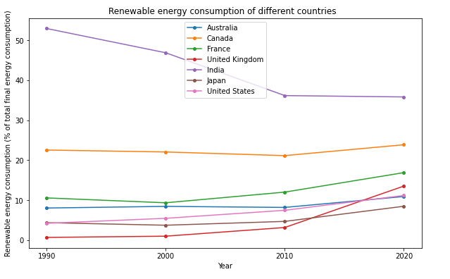

LINE GRAPH 2: From the above two graphs we can see that the power consumption of all countries has been rising continuously until the year 2000 and then after it has started to reduce little by little until 2010. The reason for this can be deduced as proportional to the renewable energy consumption increasing after the year 2010. We can also see that India had been consuming the most renewable energy for a very long time with Canada being in the second place.

HEAT MAP: Here we have a description of the population over several years as given by the statistics method. Here we can see that the std and mean is decreasing slowly as time goes.

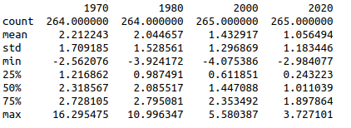

This Heatmap shows us that India is the highest to the electricity access than other countries which in-turn leads to high arable land for agriculture. It also has less urban population. United States stand last in access to electricity with very less arable land as a result.